
Easy Read Service Users guide to Day Opportunities
Just Homes Care
Your Care – Your Choice

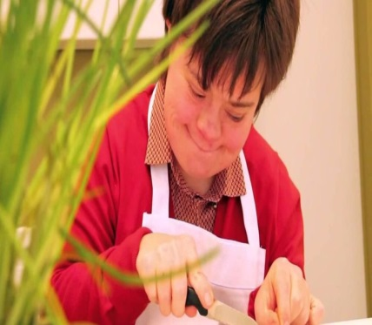
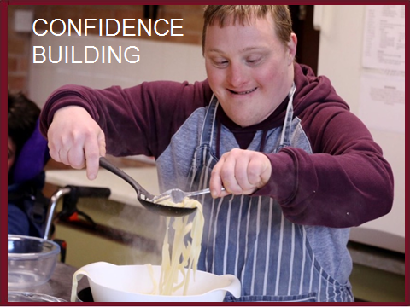

Page 2

Who are Just Homes Care?
Just Homes Care is a company that supports people all over West Yorkshire



We support all ages, from young adults to elderly with disabilities

Some people we support have learning difficulties, while others have mental health needs or physical disabilities


We understand that every individual is different and so provide support that is person-centred and full of choice

We are registered with the CQC – they regularly inspect our services to ensure your care is safe and effective


Page 3

It’s all about YOU



Choose how you are supported: we will always listen to you
Choose the days and times you want to attend
Choose what you want to do

Page 4

How can we support YOU?
We will support you in a person centred way to meet your goals


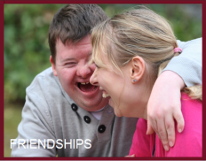
We can support you to go out in the community making new friends


We can support you to find paid or voluntary work

We want to support you to make your own choices and lead the life you want

Page 5

Things we do….
Gardening/ pot plants/ vegetables
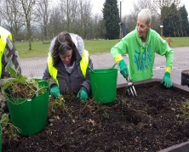

Swimming

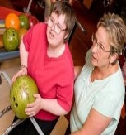
Bowling


Rambling/ walking group

Page 6


Things we do……
Horse Riding
cooking
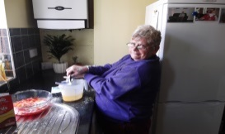
Cooking and baking sessions

Discussion/ Community Group


Trips to the cinema

Page 7

Things we do…….


Karaoke
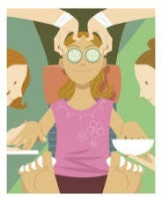
Exercise to music
Evening Discos
Pampering Sessions

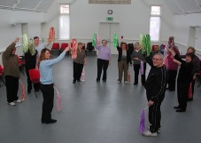


Page 8

Things we do…….
Crafts and Arts
Pub visits
Games sessions
Fishing trips







Page 9

Things we do……..
and much more……
Cycling
IT sessions
Gym sessions
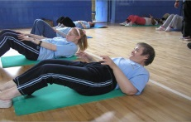




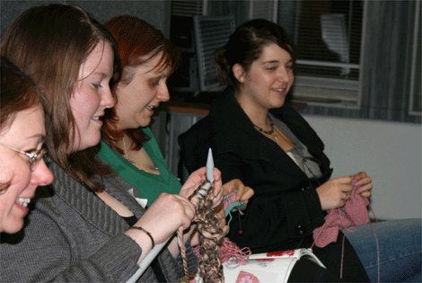

Page 10


Hobbies and Interests…
We will find out the things you like to do and anything new that you would like to try
It is important to remember that if you do not want to do something, then you can stop whenever you like
If you have a hobby, we will support you to continue this and help find others who like to do the same thing




WHAT’S ON

Will help you to find new opportunities and events that you may enjoy

Page 11




Support through Advocacy…
We can support you to have your voice heard and make decisions about your life; your views will be respected
We can also help you to make complaints if you are unhappy or feel you have been treated unfairly

We will make sure that others understand your decisions and that they are put into place

Page 12





Our Staff…
They will get to know you and find out how you like to be supported
They will always treat you with respect and dignity, treating you always as an individual
All of our staff are highly trained and are DBS checked before they begin work

We will try to find people who have similar interests to you and you can have a say on who supports you and how

Page 13

If you want to be supported by Just Homes Care…
To access our services you can contact:
Leanne Tunstall

Westfield Centre
122 Westfield Lane
South Elmsall
WF9 2PU
01977 640333
01977
Leanne.tunstall@justhomescare.co.uk

