
Just Homes Care
Your Care – Your Choice

Easy Read Service Users guide to Supported Living

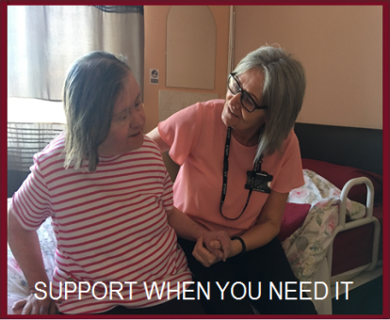
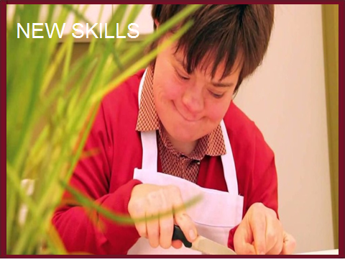

Page 2

Who are Just Homes Care?
Just Homes Care is a company that supports people all over West Yorkshire


We support all ages, from young adults to elderly with disabilities


Some people we support have learning difficulties, while others have mental health needs or physical disabilities


We understand that every individual is different and so provide support that is person-centred and full of choice


We are registered with the CQC – they regularly inspect our services to ensure your care is safe and effective



Page 3

It’s Your Choice…



Choose how you are supported: we will always listen to you and your family and friends
Choose who you live with: each home is different, with new friends waiting at each place
Choose where you live: Just Homes Care has a variety of houses within the Wakefield district that may suit you
Page 4

How can we a support you?

We can support you however you need, this could be from a few hours a week to 24 hours a day


We will support you directly and in a person centred way to meet your goals


We can support you to go out in the community, make new friends and have new exciting experiences


We want to support you to make your own choices and lead the life you want
Page 5
Your Support Plan…

Just Homes Care will always help you to make the decisions about your support


We promise to work with you, and those around you, to find out your needs, what you like and what you do not like to do


We will have meetings to plan what you will do each week and to decide how we can support you in the future

We promise to support you the way you want to be supported. If you are unhappy, we will listen and change things
Page 6

Support to Communicate…

We will spend time finding out how you like to communicate

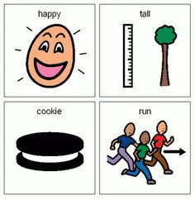
This could be through easy words, pictures or signals. It’s down to you


We may use British Sign Language or Makaton to help you communicate

Your support worker will help you by showing others how best to communicate with you too
Page 7
Support to Communicate…


We will give you information about your support in ways that are easy for you to understand
If you need, we can support you to get the information through Audio or Braille



We will create a file called All About Me, which will tell your support team all about you
You can use this file to tell others what you like to do and the choices you like to make
Page 8
Become more Independent…

We will help you to become more independent and more confident, supporting you to make decisions about your life


We can support you to choose what you eat and how to dress, as well as helping you to manage your money


We can support you to go out into the community, meeting new people and maybe even getting a job

We will try to provide you with the support to be able to do more things for yourself – we want to give you independence
Page 9
Support with Personal Care…

We promise to always treat you with dignity and respect when providing you with personal care


You will be able to have a say in whether or not your support worker is a man or a woman


We will support you to remain active and have a healthy diet

If you take medicine we will help you/remind you so that you don’t forget, and will support you to go to the doctors if you are ill
Page 10
Supporting you at Home…


We always respect the rules and privacy of your home


We can support you in household activities, helping you to be more involved


We can support you with tasks like keeping your home clean, doing your shopping and to managing your bills and tenancy

If you do not wish to live on your own, we can support you in a shared home, living with other people just like you
Page 11

Hobbies and Interests…


If you have a hobby, we will support you to continue this and help find others who like to do the same thing

Will help you to find new opportunities and events that you may enjoy


We will find out the things you like to do and anything new that you would like try


It is important to remember that if you do not want to do something, then you can stop whenever you like
Page 12

Support through Advocacy…

We can support you to have your voice heard and make decisions about your life; your views will be respected

We will make sure that others understand your decisions and that they are put into place




We can also help you to make complaints if you are unhappy or feel you have been treated unfairly
Page 13

Our Staff…

All of our staff are highly trained and are DBS checked before they begin work


They will always treat you with respect and dignity, treating you always as an individual


They will get to know you and find out how you like to be supported


We will try to find people who have similar interests to you and you can have a say on who supports you and how
Page 14

Support with Complaints…

We have a complaints procedure, where you can tell us if you are not happy with your support – we take all complaints seriously

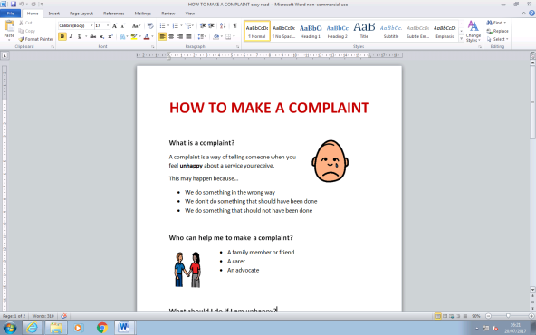
We have an easy read complaints procedure and you will be supported throughout

We encourage everyone to complain when they see things that aren’t right – we want to keep everyone safe and happy

Health and safety checks are frequently carried out, along with risk assessments to ensure everyone is supported safely
Page 15

If you want to be supported by Just Homes Care…
To access our services you can contact:

Leanne Tunstall
Westfield Centre
122 Westfield Lane
South Elmsall
WF9 2PU
01977 640333
01977
Leanne.tunstall@justhomescare.co.uk

