KEEPING ADULTS SAFE FROM ABUSE AND NEGLECT

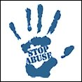
It’s everybody’s business…
This leaflet is about abuse of adults and what YOU can do about it.

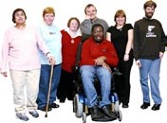
Vulnerable adults are people who cannot take care of themselves or cannot stop someone else form hurting or abusing them.
Abuse is when someone does or says something to you which makes you unhappy, scared or angry and does not feel right to you.

Any abuse is WRONG.
Abuse can happen ANYWHERE.
It can be done by ANYONE, even people that you know.

Abuse can be:

Physical – things like hitting, kicking and not giving you the right medicine
Financial – someone taking your money or things that belong to you, or if someone does not let you choose how to spend your money
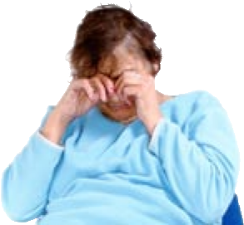
Emotional – when someone makes you feel scared or makes fun of you
Sexual – when someone touches you where you do not want to be touched or makes you do sexual things that you do not want to do
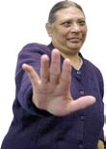
Discrimination – being treated unfairly because of things like the colour of your skin, a disability or your age
Neglect – when you are not given the things you need, like clean clothes, food or help when you need it
Institutional – when you are not treated properly by people like staff in a care home, hospital or supported living services

What should I do if I am worried about being abused?
Tell someone you trust as soon as you can. They will help you to stop the abuse.
They might have to get help from the police or a social worker to make sure that you are safe.

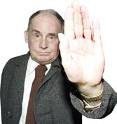
Remember:
Abuse is not your fault.
No one should abuse you.
Everyone has the right to live safely

Just Homes Care Limited Office: 01977 644322
Social Care Direct: 01977 644322
Police (non-emergency): 101

